Terna Engineering College
Computer Engineering Department

Class: TE Sem.: VI

Course: System Security Lab

PART A
(PART A : TO BE REFERRED BY STUDENTS)
Experiment No.01
A.1 Aim:
Design and Implementation of a product cipher using Substitution and Transposition ciphers

A.2 Prerequisite:
1. Basic Knowledge of Cryptography.
2. Knowledge of Substitution Cipher techniques.

A.3 Outcome:
After successful completion of this experiment students will be able to
apply the knowledge of symmetric cryptography to implement simple ciphers.
A.4 Theory:
- Cryptography is art of achieving security by encoding message to make it non readable.
There are two types of cryptographic algorithms:
- Substitution and
- Transposition.
Product cipher is combination of both these types to achieve better effect of security.
An original message is known as the plaintext, while the coded message is called the cipher text.

The process of converting from plaintext to cipher text is known as enciphering or encryption; restoring the plaintext from the cipher text is deciphering or decryption.

The many schemes used for encryption constitute the area of study known as cryptography. Such a scheme is known as a cryptographic system or a cipher.

Techniques used for deciphering a message without any knowledge of the enciphering details fall into the area of cryptanalysis.

Cryptanalysis is what the layperson calls “breaking the code.”The areas of cryptography and cryptanalysis together are called cryptology.
- Cryptography is art of achieving security by encoding message to make it non readable. There are two types of cryptographic algorithms: Substitution and Transposition. Product cipher is combination of both these types to achieve better effect of security.
- Substitution Cipher: Additive or Shift or Caesar Cipher algorithm is cryptographic algorithm invented by Caesar. It is substitution based algorithm.

- Symmetric Cipher Model

A symmetric encryption scheme has five ingredients (Figure 2.1):

• Plaintext: This is the original intelligible message or data that is fed into the algorithm as input.

• Encryption algorithm: The encryption algorithm performs various substitutions and transformations on the plaintext.

• Secret key: The secret key is also input to the encryption algorithm.The key is a value independent of the plaintext and of the algorithm.The algorithm will produce a different output depending on the specific key being used at the time.The exact substitutions and transformations performed by the algorithm depend on the key.

• Ciphertext: This is the scrambled message produced as output. It depends on the plaintext and the secret key. For a given message, two different keys will produce two different ciphertexts.The ciphertext is an apparently random stream of data and,as it stands,is unintelligible.

• Decryption algorithm: This is essentially the encryption algorithm run in reverse. It takes the ciphertext and the secret key and produces the original plaintext.

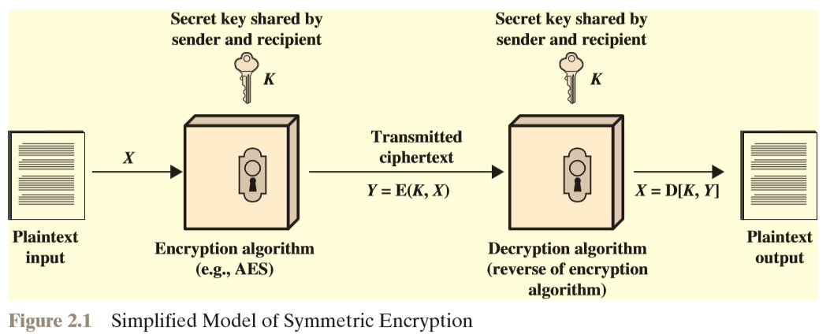

There are two requirements for secure use of conventional encryption:

1. We need a strong encryption algorithm.At a minimum, we would like the algorithm to be such that an opponent who knows the algorithm and has access to one or more ciphertexts would be unable to decipher the ciphertext or figure out the key.This requirement is usually stated in a stronger form:Theopponent should be unable to decrypt ciphertext or discover the key even if he or she is in possession of a number of ciphertexts together with the plaintext that produced each ciphertext.

- Sender and receiver must have obtained copies of the secret key in a secure fashion and must keep the key secure. If someone can discover the key and knows the algorithm,all communication using this key is readable.

We assume that it is impractical to decrypt a message on the basis of the ciphertext plus knowledge of the encryption/decryption algorithm. In other words, we do not need to keep the algorithm secret; we need to keep only the key secret.

This feature of symmetric encryption is what makes it feasible for widespread use. The fact that the algorithm need not be kept secret means that manufacturers can and have developed low-cost chip implementations of data encryption algorithms.

These chips are widely available and incorporated into a number of products.With the use of symmetric encryption, the principal security problem is maintaining the secrecy of the key.

Let us take a closer look at the essential elements of a symmetric encryption scheme, using Figure 2.2. A source produces a message in plaintext, X=[X1,X2,X3, …….. ,Xm] .

The M elements of X are letters in some finite alphabet. Traditionally, the alphabet usually consisted of the 26 capital letters. Nowadays, the binary alphabet {0, 1} is typically used.

For encryption, a key of the form K=[K1,K2,K3,……,Kj] is generated. If the key is generated at the message source, then it must also be provided to the destination by means of some secure channel.

Alternatively, a third party could generate the key and securely deliver it to both source and destination.
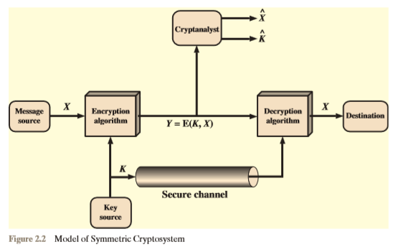

With the message and the encryption key K as input, the encryption algorithm forms the ciphertext Y=[Y1,Y2,Y3,………..,Yn].We can write this as;
Y=E(K,X)
This notation indicates that Y is produced by using encryption algorithm E as a function of the plaintext X , with the specific function determined by the value of the key K .
The intended receiver, in possession of the key, is able to invert the transformation:
X=D(K,Y)
An opponent, observing Y but not having access to K or X , may attempt to recover X or K or both X and K .It is assumed that the opponent knows the encryption (E) and decryption (D) algorithms.If the opponent is interested in only this particular message,then the focus of the effort is to recover X by generating a plaintext estimate X .Often,however,the opponent is interested in being able to read future messages as well,in which case an attempt is made to recover K by generating an estimate K.

A.5 EXAMPLE:
- Plaintext: CryPto(Sender’s input)
Key: 5(agreement key, here input)
Cipher text: (C+5)(r+5)(y+5)(P+5)(t+5)(o+5)
: HwdUyt(output)
- Cipher Text: XdkcZm(Receiver’s Input)
Key: 5(agreement key, here input)
Plaintext: CiphEr (output)

A.6 ALGORITHM:
@Encryption.....

A - Substitution Cipher
1. Take Value of Plaintext.
2. Take Value of Key.
3. Run the loop n times here n will be the length of the text.
4. Convert string into characters and that same time add with Key.
5. After Addition mod 26 or 125 can be used depending where you want to limit that entry of plain text.
6. Then save and convert the calculated part (character) into a string or string Buffer.
7. Now the Final output will be the actual Cipher Text.

B - Transposition Cipher
1. Input of this Cipher will be the output from the Substitution Cipher.
2. Convert into matrix with the help of the key (key is different these time).
3. And will the help of the matrix, just lay down the content of the matrix or save the content into a simple string.
4. This String will be the Cipher Text.

@Decryption.....
Now out steps will be in the reverse order.
Hence.
A - Transposition Cipher-
1. Input here will be the cipher text.
2. Take Value of Key.
3. Insert this Cipher Text into the Transposition Cipher whole algorithm remains same.
It just the value of k will change (k = cipher text/k).
4. Collect the characters and built it into a string.
5. That String will act as text that will be later interested into Substitution for the final decryption.

B - Substitution Cipher
1. After taking the input.
2. Use the same key
3. Follow the Same producer as encryption, here the only difference is that instead of addition we will perform subtraction with the help of the key.
4. The result will be the Plain Text. And the code is finally decrypted.

PART B
(PART B : TO BE COMPLETED BY STUDENTS)
(Students must submit the soft copy as per following segments within two hours of the practical. The soft copy must be uploaded on the Blackboard or emailed to the concerned lab in charge faculties at the end of the practical in case the there is no Black board access available)

Roll No. C-54 | Name: Quazi Md Moinuddin
Class : TE Comps C | Batch :C-3
Date of Experiment: 23.01.25 | Date of Submission 5.02.25
Grade :

B.1 | Output of Product Cipher:
 | 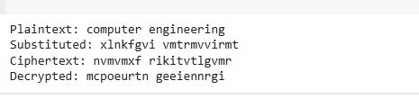
B.2. | Source Code of Product Cipher:
import string

def substitution_encrypt(plaintext, substitution_key):
alphabet = string.ascii_lowercase
substitution_dict = {alphabet[i]: substitution_key[i] for i in range(len(alphabet))}
encrypted = ''.join(substitution_dict.get(char, char) for char in plaintext.lower())
return encrypted

def substitution_decrypt(ciphertext, substitution_key):
alphabet = string.ascii_lowercase
reverse_dict = {substitution_key[i]: alphabet[i] for i in range(len(alphabet))}
decrypted = ''.join(reverse_dict.get(char, char) for char in ciphertext.lower())
return decrypted

def transposition_encrypt(plaintext, transposition_key):
n = len(transposition_key)
rows = [plaintext[i:i+n] for i in range(0, len(plaintext), n)]
encrypted = ''
for index in transposition_key:
encrypted += ''.join(row[index] if index < len(row) else '' for row in rows)
return encrypted

def transposition_decrypt(ciphertext, transposition_key):
n = len(transposition_key)
num_rows = len(ciphertext) // n + (1 if len(ciphertext) % n else 0)
matrix = ['' for _ in range(num_rows)]
counter = 0
for index in sorted(transposition_key):
for i in range(num_rows):
if counter < len(ciphertext):
matrix[i] += ciphertext[counter]
counter += 1
decrypted = ''.join(matrix[i][j] for i in range(len(matrix)) for j in range(len(matrix[i])))
return decrypted

# Example usage:
plaintext = "computer engineering"
sub_key = "zyxwvutsrqponmlkjihgfedcba" # Reverse alphabet
trans_key = [2, 0, 3, 1] # Permutation for transposition

# Encryption
substituted = substitution_encrypt(plaintext, sub_key)
ciphertext = transposition_encrypt(substituted, trans_key)

# Decryption
trans_decrypted = transposition_decrypt(ciphertext, trans_key)
decrypted = substitution_decrypt(trans_decrypted, sub_key)

print(f"Plaintext: {plaintext}")
print(f"Substituted: {substituted}")
print(f"Ciphertext: {ciphertext}")
print(f"Decrypted: {decrypted}")

B.3 | Question of Curiosity:  - What are the Ciphers?  - What are the different types of Cipher?  - What is Substitution Cipher? Explain with an example.  - What is transposition Cipher? Explain with an example.  - Explain Affine Cipher.  - How does a product cipher combine substitution and transposition techniques to enhance security?  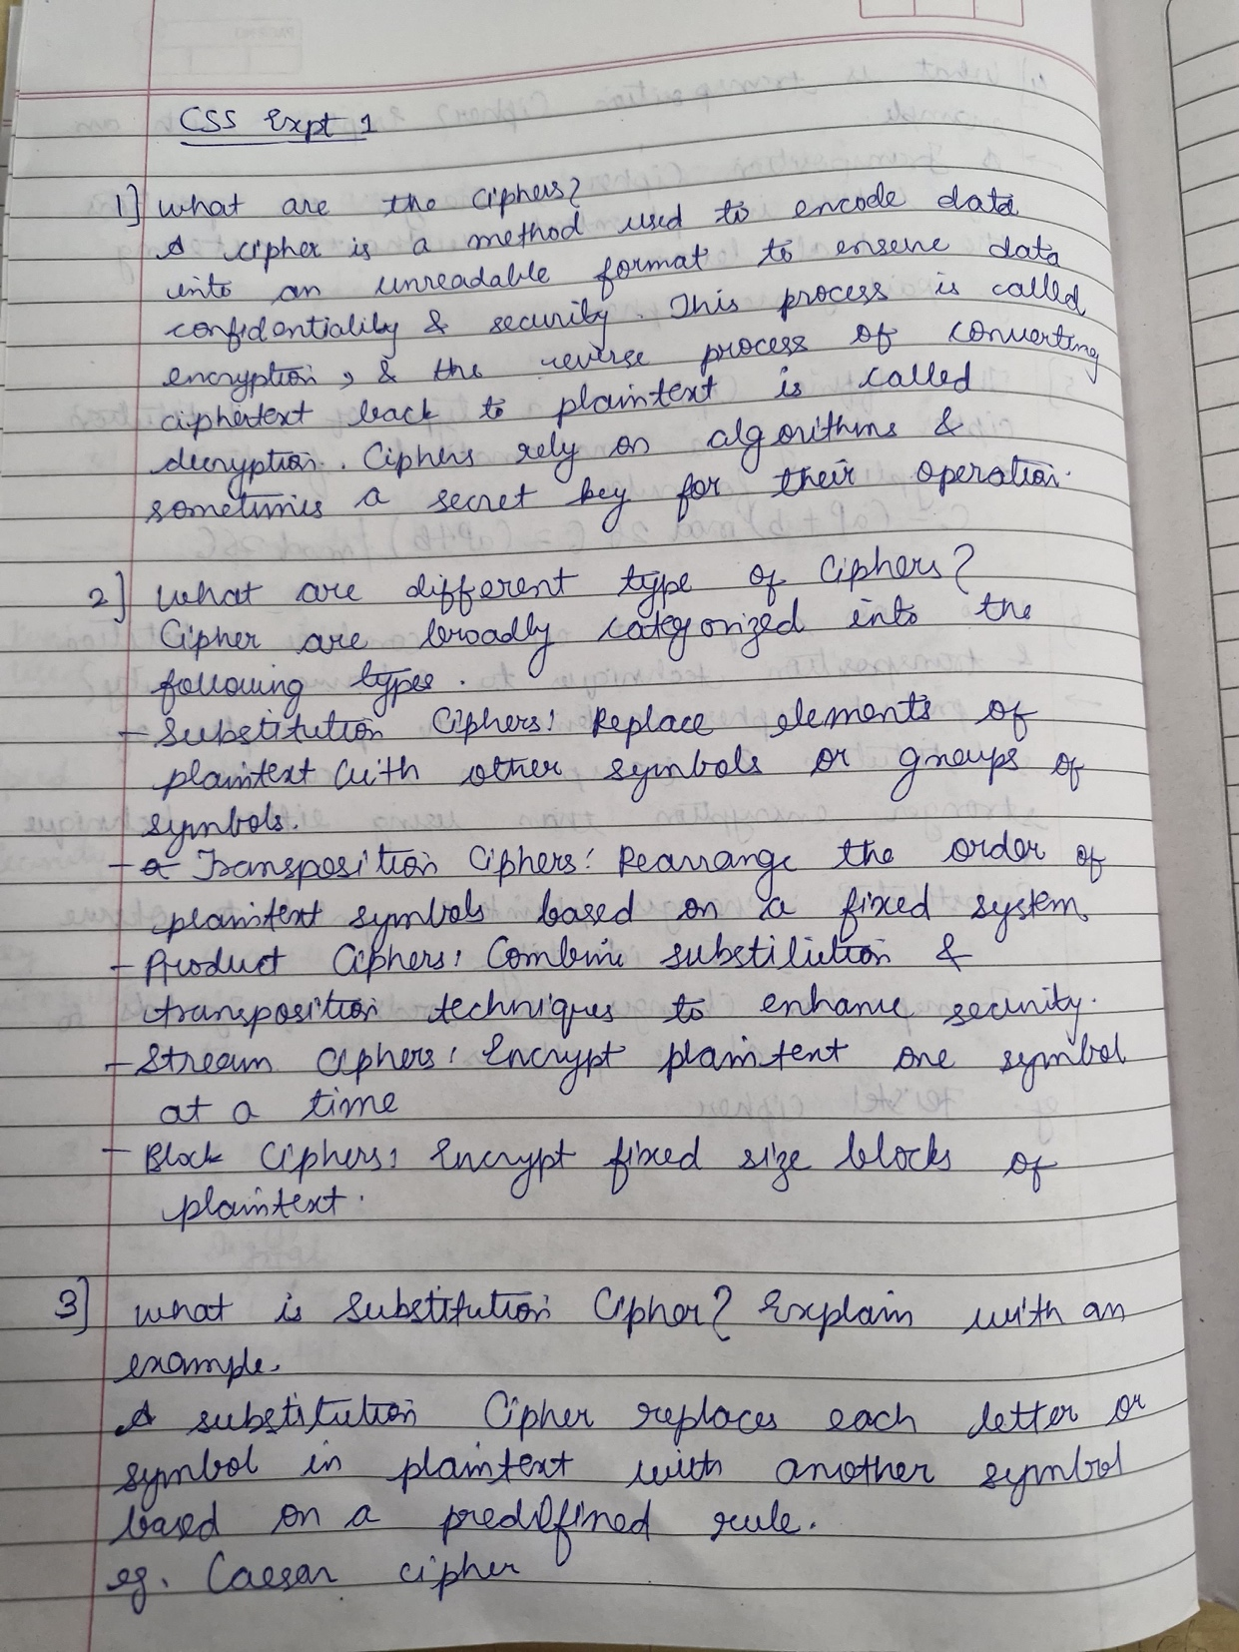  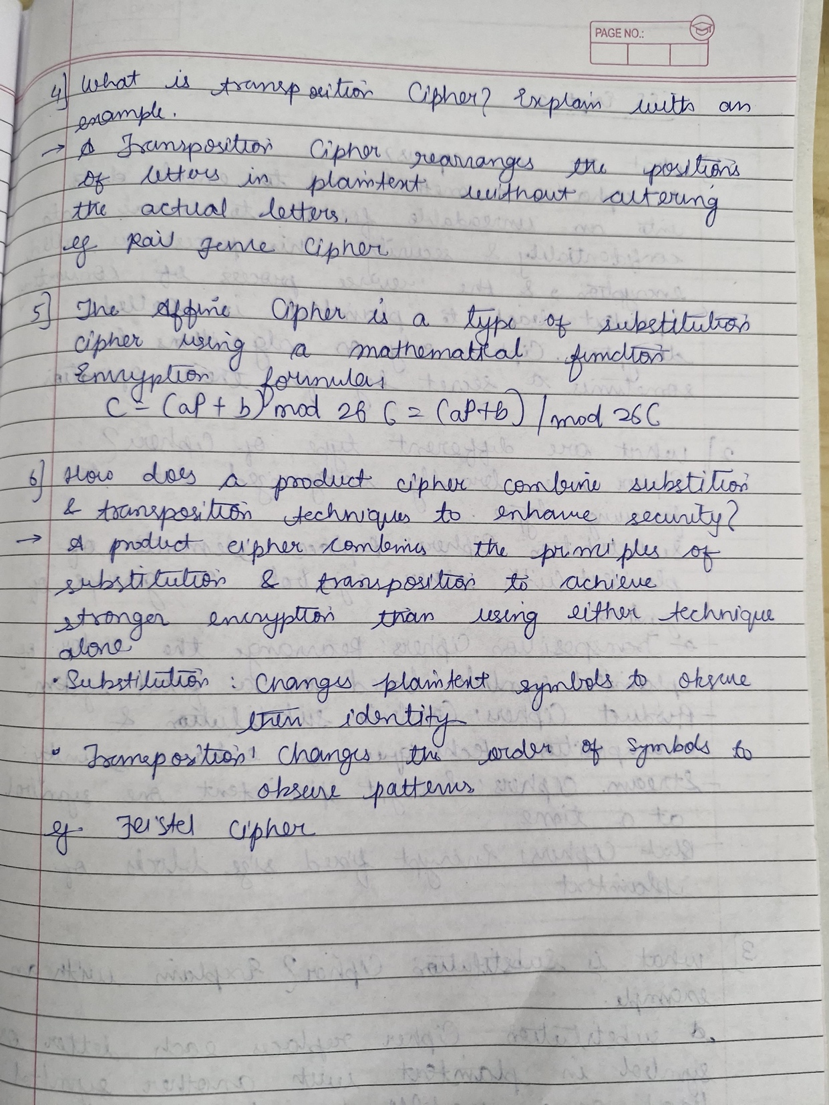
B.4 | Conclusion:  In conclusion, the implementation of a product cipher using substitution and transposition ciphers can provide a more robust and secure encryption scheme.  However, careful consideration must be given to key management, algorithm selection, and the potential impact on computational efficiency. Additionally, for practical security applications, modern cryptographic methods, such as advanced block ciphers and asymmetric key algorithms, are typically preferred.

